Table of Contents

Overview 2

Developer Notes 3

MISC 5

# Overview

This document describes the changes made for the **TaskID**#: ITJN028-VII, link -

<http://web.jmgrovebuildingsupply.com/Sr_App/TaskGenerator.aspx?TaskId=398&hstid=553>

Following souce code files are modified and committed GitHub repository :

|  |  |
| --- | --- |
| **Fine Name** | **Path** |
| 1. EditUser.aspx | https://github.com/jmgrove2016/JGProspectLive/blob/nandc/JG_Prospect.web/Sr_App/EditUser.aspx |
| 1. EditUser.aspx.cs | https://github.com/jmgrove2016/JGProspectLive/blob/nandc/JG_Prospect.web/Sr_App/EditUser.aspx.cs |
| 1. InstallUserBLL.cs | https://github.com/jmgrove2016/JGProspectLive/blob/nandc/ JG_Prospect.BLL/ InstallUserBLL.cs |
| 1. InstallUserDAL.cs | https://github.com/jmgrove2016/JGProspectLive/blob/nandc/ JG_Prospect.DAL/ InstallUserDAL.cs |
| 1. Script HR Edit Page ITJN028-VII v1.0.sql | https://github.com/jmgrove2016/JGProspectLive/blob/nandc/Database Scripts/nandc/Script HR Edit Page ITJN028-VII v1.0.sql |
| ITJN028-VII - HR edit page_05032017.docx | https://github.com/jmgrove2016/JGProspectLive/blob/nandc/ITJN028-VII - HR edit page_05032017.docx |

The Script HR Edit Page ITJN028-VII v1.0.sql file contains following objects and scripts:

|  |  |
| --- | --- |
| 1. usp_GetUsersNDesignationForSalesFilter |  |
| 1. usp_GeAddedBytUsersFilter |  |
| 1. JG_PARAMETERS Table |  |
| 1. Script to update JG_PARAMETERS Table |  |

# Developer Notes

This section lists the assumptions, feedback, questions, issues, changes, testing done etc. for completing this task.

|  |  |
| --- | --- |
|  | **Requirement# # 1) Designations** – This is already implemented. The values are stored in tbl_Designation table, proc UDP_GetAllDesignationsForHumanResource populates the drop-down field, and there is no UI for this. So no changes are made for this req. |
|  | **Requirement# A1) – ii) –** To browse to ID# link, right-click and select open page |
|  | **Requirement# 2a) –** Apart from the designations listed, currently 'Sales Manager' and 'Operations Manager'  Users are also shown. I am assuming there would be no change to this criterion. |
|  | **Requirement# 3i) “2 weeks (pay period!)” –** this will get records for last 14 days, including current date.  For example if today is 4/29/2017, the select period would be from 4/16/2017 To 4/29/2017 |
|  | **Requirement# 3)** – Please note as per the existing functionality, only “Selection Period” filters is applied to the Pie chart.And other filters (Status, AddedBy etc.) are not applied). All filters are applied to fetch data for grid. |

|  |  |
| --- | --- |
|  | **EditUser.aspx**   * There are about 649 records in the users grid. To format all the Status drop-down fields in the grid is taking too long, and the browser is returning timeout message. I tested with 100 records in the grid, and it works fine.   This is existing issue in interview.jmgrovebuildingsupply.com portal: |

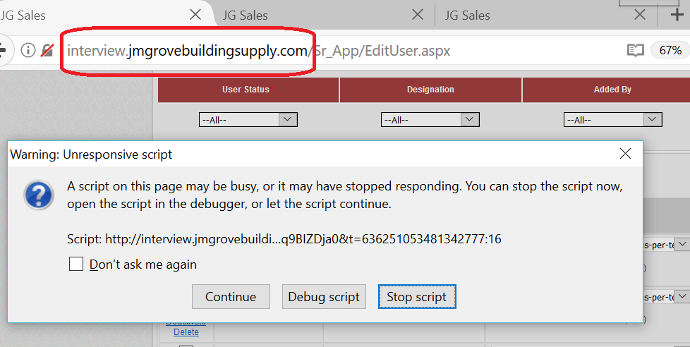

# MISC

Please let me know if you need anything else and I would be happy to work.

**Thank you!**

Nand Chavan